5D4N HO CHI MINH – CU CHI – VUNGTAU – MEKONG DELTA
DAY 1: HO CHI MINH – ARRIVAL ( D )
Upon arrival at Tan Son Nhat International Airport, our representative will meet and transfer to city center to visit Hundreds Years Red Cathedral, Old Post Office, People’s Committee Hall, French Opera House. Dinner at local restaurant, overnight at hotel in Ho Chi Minh City.

Meals: 1 Dinner
Accommodation: Overnight in Saigon
The distance: Tan Son Nhat Airport – Saigon Center: 20km – 20 minutes for transfer.

DAY 2: HO CHI MINH – CU CHI TUNNELS – VUNG TAU (B/L/D)
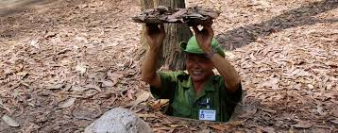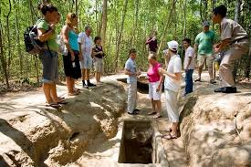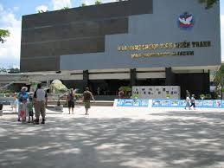
Cu Chi Tunnels War Museum
After breakfast, proceed to Cu Chi Tunnels – a network of tunnels more than 200km long and 3 – 8 m deep, dug during the warfare days. After lunch, transfer to Vung Tau - situated 125km south west of the city. It is a famous beach resort with long white sandy beaches and warm water whole year round. Dinner at local Restaurant & overnight at Vung Tau.

Meals: 1 Breakfast + 1 Lunch + 1 Dinner
Accommodation: Overnight in Vung Tau
The distance: Saigon – Cu Chi: 75km – 1.5 hours for transfer.
Saigon – Vung Tau: 120km – 3 hours for transfer

DAY 3: VUNG TAU - HO CHI MINH CITYTOUR (B/L/D )
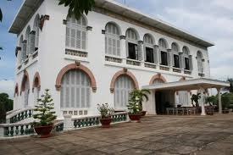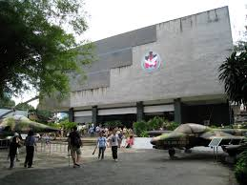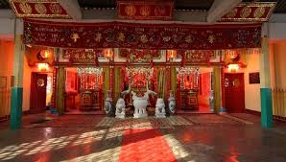
After breakfast, transfer to visit The Whale Temple, St. Jacque Janerio, 18 Meters High Goddess of Mercy, White Palace. Afer lunch at Vung Tau Local Restaurant, transfer back to Ho Chi Minh City visit War Museum, China Town withThien Hau Temple, Lacquerware Factory and Handicraft Center. Dinner at local restaurant & overnight at Ho Chi Minh.

Meals: 1 Breakfast + 1 Lunch + 1 Dinner
Accommodation: Overnight in Saigon
The distance: Vung Tau - Saigon: 120km – 3 hours for transfer

DAY 4: HO CHI MINH - MYTHO (B/L/D)
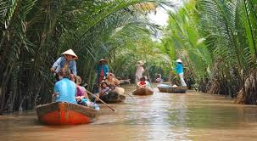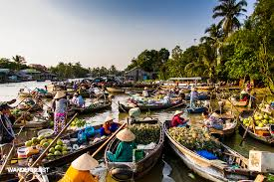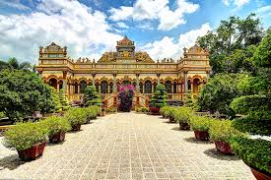
My Tho Vinh Trang Pagoda
After breakfast, depart for My Tho , visit Vinh Trang pagoda, take a leisurely boat ride along the river visit to Thai Son Islet and The Fruit Garden to enjoy the fresh fruit. Lunch with Vietnamese food serve with special “Elephant Ear Fish”, back to Ho Chi Minh City. Shopping at Ben Thanh Market & Dong Khoi Str. Dinner will be served on Saigon River Cruise with show entertainment along the Saigon River at the end of the day. Overnight in Ho Chi Minh.

Meals: 1 Breakfast + 1 Lunch + 1 Dinner
Accommodation: Overnight in Saigon
The distance: Saigon – Mekong Delta: 75km – 2 hours for transfer

DAY 5: HO CHI MINH DEPARTURE (B)
After breakfast, free at leisure then transfer to airport for flight home with sweet memories.
Meals: 1 Breakfast
The distance: Saigon Center - Tan Son Nhat Airport: 20km – 20 minutes for transfer.

SEQUENCE OF ITINERARY SUBJECT TO LOCAL ARRANGEMENT

PRICE INCLUDE:
- Accommodation – as hotel in the list or similar – based on Twin/Double/Triple sharing
- Tour guide: English or Chinese speaking guide during the tour.
- Daily ABF and meals as mentioned in the program
- Shows and sightseeing in schedule.
- Transportation by private air-conditioner.
01 bottle ( 500 ml )of drinking water for each pax per day.
- Meals (Vietnamese Food & Chinese Food) as the tour code ( B: Breakfast, L: lunch, D: Dinner) 8-10 USD/meal/pax + One dinner on Saigon Cruise + 1 Buffet + 1 Mekong Special Food ( Elephant Ear Fish, Big Head Prawn & Dinosaur Eggs ).
- Sampan in Mekong Delta as mentioned in the program
PRICE EXCLUDE:
- International / Domestic flight ticket & airport tax (if have)
- Personal expenses: Tel, Fax, Mini Bar, Laundry,etc.
- Personal travel insurance
- Compulsory Tip for local guide and driver (USD/pax/day)

Group Size | Tips in USD
2 – 4pax | 6
5-7pax | 5
8 - up | 3

- Additional Meal will be surcharge 10usd/pax/meal.
- Surcharge with other languages guide
- Surcharge at hotel case by case
  - Chinese New Year (TBA)
  - Gala Dinner on X’Mas (24, 25 Dec ) & New Year 31 Dec.

Hotel category  Hotel listed or Similar |  | All rates are next in USD/PAX  valid Jan - Dec, 2020
 |  | Tour by private car / bus with private guide
SAIGON | VUNG TAU | 2 | 3-4 | 5-6 | 7-9 | 10-12 | 13-15 | 15+1 | 20+1 | 25+1 | 30+1 | SS
Le Duy 3*  Bloom Saigon 3*  Alagon Western 3*  Ambassador 3*  Aluna 3* | Ambassador 3*  Green 3* | 398 | 351 | 291 | 271 | 261 | 242 | 238 | 226 | 223 | 213 | 90
MuongThanh 4*  Palace Saigon 4*  Athena Saigon 4*  Cicilia 4* | Muong Thanh 4*  New Wave 4* | 428 | 383 | 321 | 301 | 291 | 271 | 268 | 258 | 256 | 243 | 120

NOTE

The timing of sightseeing points shall be fixing by local operator due to traffic and weather conditions, however all points must cover unless amendment or cancellation make by clients themselves (Non-refundable for any cancellation that made by clients)

Tour and price are subject to change without notice or in case of deduct number of pax in quoted group.

Small deviations in the tour program are sometimes necessary, depending on weather, road conditions, flight schedules and room availability.

Supplement charge for room rate in peak dates depends on the hotel category used. Compulsory gala dinner on X’mas, New Year’s Eve & Lunar New Year’s Eve to be advised upon booking. Prices for group of 15 persons up in 5 stars hotels sometime requires to re-quote bases on the hotel policy

01 FOC for tour leader based on twin sharing basis include breakfast (domestic air ticket is not applicable).

BUS

Group Size | Kind of Transportation
1-2 pax | 4 seater
3 pax | 7 seater
4-9pax | 16 seater
10-18 pax | 30 seater
19-21 pax | 35 seater
22 – 42 pax | 45 seater
TRAVEL TIPS:

The tour guide will introduce some optional.
Vietnamese traditional massage in Saigon: 1h30 minutes including tips: 20 USD/ pax
*Commisstion 10% for tour leader

CHILD POLICY

- Infant below 2 years old sharing same room with parents is free of charge.
- Child below 12 yrs old sharing same room with 1 ADL is charged for 90%.
- Child below 12 yrs old with extra bed and sharing same room with parents is charged for 65%.
- Child below 12 yrs old No extra bed & sharing same room with parents is charged for 55%

